**carriersystemshistory**

**Carrier Systems History**

**A Data Communication Historical Series**

**By Bob Pollard**

**Overview of data carrier systems development**

Note: A voice channel, a broadband channel or the individual sub channels within a voice channel or broadband channel may be referred to as a band(s).

**Carrier Definition:**

1. A continuous pre-determined frequency (Hertz / Hz) that can be modulated by data signals carrying information.
2. A voice grade channel (line / facility) or larger (microwave) may be divided in sub carrier frequencies. Example: a voice grade channel provides a bandwidth of 4000 Hz with, depending on the equipment, a usable range that would probably fall somewhere between 300 to 3600 Hz. At first this 3000-3300 Hz usable bandwidth was divided into individual low speed 300 Hz channels (bands), with a buffer frequency of 10 to 30 Hz between each channel (band). This would provide 10 individual channels over one voice grade line. Later, as equipment and conditioning capabilities improved, and considering bit per second rates (bps) and type of equipment used, this was increased to 20 (approximately 150Hz channels). The individual sub channels would normally have a Carrier device, or the later developed MODEM, on each end of the individual sub channel. The lowest frequency (bandwidth) sub-channel(s) was used for the lowest bit per second rates. If the bit per second rate of most of the sub channels was at the low end (50-WPM) more than 30 sub channels (bands) could be placed on the voice grade channel (line). There could be an intermix of sub channel bandwidths (bps rates), low, medium and high speeds, and the number that could be accommodated on a voice grade channel would be determined by the frequency requirement for each sub channel.
3. Carrier Device: pre-MODEM modulator-demodulator device.
4. Depending on a person’s age, the term Carrier may also be used to specify a MODEM by maintenance personnel i.e. the 300 Hz channel (line) has a Carrier on each end.
5. The term Carrier is used to identify a provider of lines and equipment or telephone service, ‘Common Carrier’.
6. Carrier Systems: Describes a network of wires and / or equipment, such as, electrical house wire or the electrical grid used by Power Companies or equipment designed to support the operation.
7. Carrier: A holder (container) used for storing and transporting (hauling) electronic devices that protects them from physical damage.
8. The term Carrier may refer to a provider of good and services (non-communication).
9. The voice grade channel (line) could span long distances and could be regenerated (amplified, conditioned and continually restored) by the common carrier (Telephone Company / other Vendor).
10. The term ‘Voice Grade Channel (line)’ is used to identify a conditioned line for voice or communications purposes. The term ‘Broadband’ is different based on the time frame under discussion. In the 1960’s broadband was used to define lines (channels) operating at 2400 to 4800 bits per second. Today broadband could define lines (channels) operating in megabit ranges. This broadband line (channel) could also be divided into sub-channels (bands), including a multiple of voice grade channels (4000Hz).

**Carrier Device / System:**

Developed and implemented by Western Union in the 1930’s this system for transmitting data utilizes a ‘Carrier’ device, using Frequency Modulation (FM) for encoding the digital signals, on a telephone type facility. A telephone line (facility/channel/band) uses AC (Alternating Current), analog signals, in order to support voice signals from a telephone. The Carrier device provided the capability to use analog signals (sub-divided frequencies) to carry digital information. The telephone line analog base frequency generated by the carrier device is referred to as the carrier (carrier frequency). When the telephone line is used for voice, a carrier frequency is not required, since the voice or music is merely amplified and sent over the telephone line in a variable frequency representing the voice signals.

The Carrier device, depending on the requirement, was designed to use (modulate) either the entire telephone channel (line) voice band or use only a small part of the total telephone voice band available frequency of 4000 hertz (cycles). In actuality only about 3000-3300 hertz (Hz) of the total 4000-hertz (Hz) bandwidth is used. The use of a Carrier device does not require a telephone line per se, but a line that provides similar features and quality and maintains proper signal conditioning, reduced noise and distortion levels can be used. When the Carrier device(s) is used on a Telephone line or a leased or private line, it generates the necessary carrier frequency. This generated carrier frequency could provide for a single high-speed service, consuming the total voice grade line capability or the voice grade line could be divided into sub carrier (low speed) frequencies. The carrier frequencies, high and low, are then modulated based on the input digital signal. This division of the line (channel) utilized for Carrier service is discussed later in this Section.

Prior to the Carrier device all data transmission used DC current for the power source, which created limitations on speed and the number of devices (terminals) that could simultaneously use the line efficiently. Also, the DC line requirement to frequently restore the power in order to maintain adequate line power levels, and the necessity to frequently regenerate the data signals, is expensive relative to the number of users a single analog line can accommodate.

The Carrier device provided a direct equipment connection from the Terminal DC line to the telephone voice grade line. One might view the Carrier device as the first MODEM since a DC signal was converted to an AC signal and then back to a DC signal at the distant end. Although the present-day MODEM can provide protocol and connection controls, error checking and correction, automatic distortion and bias correction and bit per second speed rate adjustments automatically; these features were not available when using the Carrier.

Dividing a voice channel (line) into sub-channels allows a group of local DC circuits to be routed via the Carrier devices to a distant Message Switching Center or some other individual distribution point on one voice grade channel. The voice grade channel term is used to identify the usable 3000 to 3300 Hz bandwidth on a telephone line and the quality of the line required for providing the most efficient data transfer operation. During the Carrier device days this line would not normally be used for telephone service when it is divided up for data transfer. When divided it is not necessary for an individual user or company to pay for the entire voice grade channel because one voice grade channel could be divided between many users between point A and point B (between cities). Each user would be required to pay for only their portion of the voice grade channel. The lease rate or purchase cost would be prorated based on the distance and the bit per second rate and the sub band frequency. Also, the line used need not be a telephone line, but would normally be a line of equal or greater quality. Western Union (WU) provided many of their own facilities, combined with Telephone facilities and the quality of either could be considered equal. The carrier device was designed to work on a pair of exposed land-lines.

Western Union introduced the Type 15 (Figure 1) and 20 Carrier in the 1940s, using Frequency Modulation (FM), which could provide up to 20 different frequencies or sub channels to be used on a single telephone quality line. Each individual Carrier device could be set to provide one of 20 different carrier frequencies (bands). If all 20 individual frequencies are used it would require 20 individual carrier devices, each one set at a different frequency. Each individual frequency would be modulated by the appropriate input data. A letter designation such as ‘A’ through ‘L’ was used to identify the different individual carrier frequencies. Illustrated below:

A= 525 cycles (Hz); B= 675 cycles; C= 825 cycles; D= 975 cycles; E= 1125 cycles; F= 1275 cycles; G= 1425 cycles; H= 1575 cycles; I = not used; J= 375 cycles (later addition Carriers used the low end frequency); K. & L. were available for additional use. The term Hertz (Hz) arrived later and was not used during this period.

[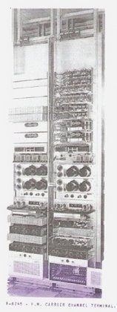](https://sites.google.com/site/mdprcp/Type15CarrierA.jpg?attredirects=0)

**Western Union Frequency Modulation (FM) Type 15 Carrier System (2 racks), ca: 1945**

**Figure 1**

In the previous example only about half the available and usable 3000 / 3300 Hz voice grade (band) frequency was utilized. A second group of Carrier devices with different individual frequencies could utilize the other half of the voice band frequency spectrum.

**Basic Modulation Schemes:**

The illustration below provides examples of three methods of modulation: ‘C’ amplitude modulation, ‘D’ frequency modulation, and ‘E’ phase modulation. Many modulation techniques for modulating the carrier frequency, ‘A’, are used and some of the basic techniques are listed and briefly described in the MODEM page.

[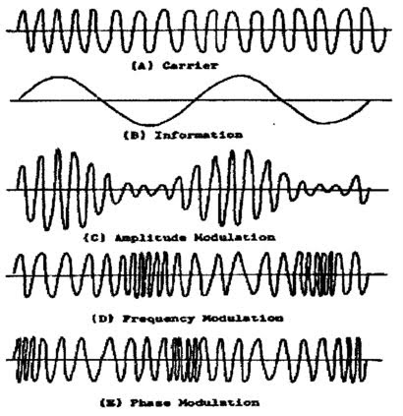](https://sites.google.com/site/mdprcp/Carrier-1.tif?attredirects=0)

The following Illustration shows how a voice grade line (usable 3000-3300 Hz) could be divided into sub-channels utilizing frequency division multiplexing based on the bit per second (bps) rate. This frequency division could be accomplished through the use of individual Carriers or by connecting a Multiplexing unit to the voice grade line. The Multiplexer would provide for all the DC side connections (multiple terminals) and in turn, on the AC side, be connected to the line. The result is the same, except the Multiplexer has the representative individual Carriers internally built into the Multiplexer. This frequency division of the channel, as can be seen in the following illustration, results in the equivalent of multiple lines (sub channels) on one voice grade channel. In turn each sub channel carrier frequency can be modulated to carry information. The frequency bandwidth of the individual sub channels dictates the bit per second rate that can be used.

This illustration represents the type of transmission speeds used in the 1950s and 1960s

[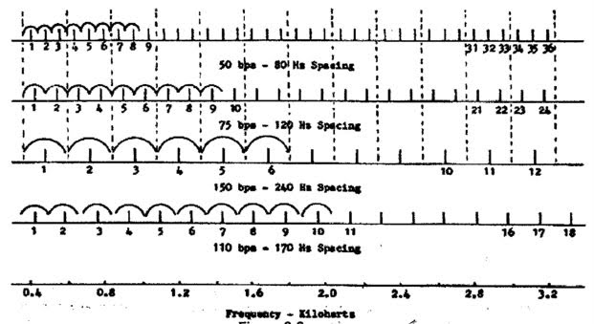](https://sites.google.com/site/mdprcp/Carrier-2.tif?attredirects=0)

The earlier Carrier devices (type 15) required manual adjustment to accommodate the various connection requirements. There were switches, meters, relays, potentiometers and test points located on the front panel of the Carrier or on a panel shared by two Carriers. Two Carriers were mounted in a shared rack. There were adjustments for maintaining correct bit positioning (bias) for the internal Carrier clocking; send and receive relays connected the DC circuit from the terminal or other device. Other adjustments and tests points provided for the testing and correction of signal distortion and equalization of internal functions. A seven-position switch on each Carrier provided for a variety of different DC circuit functions. The different switch positions and the assigned functions are listed below:

1. Duplex – extended lines.
2. Polar leg’s (lines). Two lines, polar signal.
3. Make break send (plus or zero voltage). Polar receiving would use plus and minus voltage.
4. Two grounded legs (lines) from the connected device. Make break signal.
5. Single grounded leg (line). Half duplex, send and receive same line.
6. Two Concentrator legs (lines), voltage (current) provided by the Concentrator.
7. Single Concentrator leg (line)

The Type 20 Carrier performed or provided for most of these features electronically.

All of these manual controls and adjustments along with the commonly used ‘Carrier’ (all series) were superseded through the development of the MODEM in 1962 and the RS 232 signal and connection standards.

During the pre-full-duplex MODEM days, in order to support full duplex (simultaneous operation in both directions) it was necessary to use two sub channels (bands) for one terminal (send and receive). This would involve four Carriers, one on each end of the two lines for duplex operation. Later (1960’s), two-way (duplex) communications became possible on a single channel (band) with the development of a full duplex-reverse channel MODEM (Data Set), with one on each end of the channel (line).

The following illustration provides an example of the early single line full-duplex data transmission capability, with the main sub channel (band) operating at a much higher bit per second (bps) rate than the reverse sub channel. In this example the main sub channel is used for data block transmission and the reverse direction was used to acknowledge each block as it is received. This involved two carrier frequencies, one for the main sub channel and one for the reverse sub channel. Since the bps rate for the main sub channel is the highest it would consume the majority of the telephone channel available bandwidth. In other MODEM models; A 600 bps Data Set (AT&T term) main channel transmit rate would have a reverse 5 bps rate. An 1800, 2400 or 3600 bps MODEM main channel transmission rate had a 150-bps reverse channel rate. In some cases, the higher frequencies required a broadband facility. The forward and reverse sub channel could be used for any type of data transmission.

The 300 baud full-duplex MODEM was introduced (1962), following the reverse channel MODEM, using Frequency Shift Keying (FSK) and it operated at the same bit per second rate in both directions. This full-duplex operation is possible because of different carrier frequencies (tone) used by each end. For example: one end, the ‘originate’ MODEM, may transmit a 1,070 Hertz tone for a ‘0’ and a 1,270 Hertz tone for a ‘1’ ; The ‘answer’ MODEM would transmit a 2,025 Hertz tone for a ‘0’ and a 2,225 tone for a ‘1’. Since different tones are used by the ‘originate’ and ‘answer’ MODEM, simultaneous (full-duplex) operation is possible. The Answer and Originate terms identify the different frequency(s) used by the MODEM on each end of the circuit.

Today a much faster bit per second transmission rate is possible on a voice grade facility, 3000-3300 Hertz bandwidth, using sophisticated modulation techniques. At this time the 56 Kbps (thousand bits per second) MODEM is about the limit on a pure voice grade channel (line) and it actually connects at a lower bit per second rate because of imperfect lines / equipment. This connection limit (capability) on a voice grade line usually restricts the 56Kbps connection rate to a level between 14Kbps to 50Kbps.

[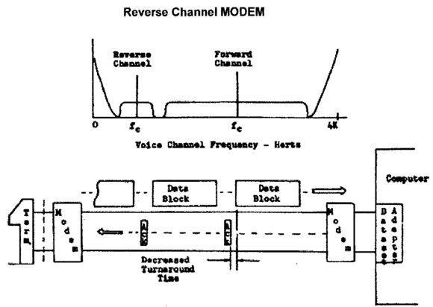](https://sites.google.com/site/mdprcp/Carrier-3.tif?attredirects=0)